SECTION V: PEDIATRIC TRAUMA PATIENT CARE GUIDELINES: BURNS

Evaluation of Burn Patients (Revision: May 2024)

Referral, Transfer and Admission

- Pediatric patients with > 20% TBSA burns or burns with concomitant inhalation injury will be stabilized and then transferred to Shriners Children’s Ohio.
- Any child with concomitant traumatic injury which poses IMMEDIATE RISK will be stabilized prior to burn center transfer.
- Any child who cannot be transferred due to weather must be stabilized and appropriately treated until the child can be safely transferred.
- Shriners Children’s Ohio is available 24/7 to assist with management of burn patients. Call 855-206-2096 and ask to speak with the Charge Nurse.

- Any pediatric patient with the following should be evaluated for potential benefit from referral and/or transfer to a specialty pediatric burn center (Shriners Children’s Ohio 855-206-2096):
- burns involving face, hands, feet, genitalia, perineum, or major joints
- partial thickness burns >10% TBSA
- any full-thickness burns
- electrical burns, including lightning
- chemical burns*
- Frostbite*
- inhalation injury without associated burns
* NOTE: all frostbite or chemical burn injuries warrant consultation with Shriner’s Burn center to determine best course of action

- If after consideration of the above, it is determined that a pediatric patient with < 20% TBSA burns requires hospital admission, the patient may be admitted to the Pediatric Trauma Service. Pediatric Surgery will manage overall care. Plastic surgery will be consulted for wound management.

Introduction
- 75% of burns are ≤ 10% Total Body Surface Area (%TBSA).
- 60% of burn victims are children ≤ 5 years of age.
- 90% of burns can be managed on an outpatient basis.
- Many pediatric burn injuries (6 - 20%) are secondary to child abuse.

Stabilization
- Avoid hypothermia – administer warmed fluids, increase ambient temperature and cover patient with warm blankets.
- Carbon Monoxide Positioning
    - Assume carbon monoxide poisoning if history of altered mental status or confinement in a burning environment
      - Automobile fumes and smoke inhalation are leading causes
    - CO affinity for Hb is 200X that of O2 leading to decreased PaO2
    - Pulse oximetry does NOT differentiate between CO and O2 and may have an inaccurate normal reading
    - CO level should be ordered on all burn patients
    - Treatment is with 100% Non-rebreather (decreases ½ life of CO to 40-80 minutes)
    - Consider Hyperbaric therapy if:
    - Loss of consciousness: syncope, seizure or alteration/loss of consciousness at any time
    - Focal neurologic signs, including confusion or cerebellar dysfunction
    - Elevated troponin, OR ischemic EKG abnormalities
    - COHgb >25%
    - Pregnant and COHgb >15
    - Metabolic acidosis without other cause
  - Cyanide Toxicity
    - Cyanide gas is a biproduct of burning nitrogen-containing polymers such as plastics, wool, or silk. A high index of suspicion should be maintained in any fire in an enclosed area where these products are present
    - Signs of exposure to cyanide include
      - Lactic acid >10 (Prevents cellular use of oxygen, causing cells to switch from aerobic to anaerobic metabolism, leading to lactic acid production.
      - High PvO2 (O2 extraction is impaired)
      - Convulsions, otherwise unexplained hypotension, respiratory failure
    - CyanoKit (hydroxocobalamin) should be administered immediately if cyanide toxicity suspected. Do NOT wait for lab test confirmation to treat.
      - CyanoKits are available in ED (2 stocked at all times) and there are many more in central pharmacy, ICU and satellite pharmacies. They are also available on the captain and lieutenant’s trucks for Lex Fire
- Maintain airway - supraglottic airway is extremely susceptible to edema/obstruction from superheated air. Consider intubation if > 40% TBSA or clinical signs of inhalation injury:
  - Hoarse voice or cry, stridor, drooling, difficulty speaking, respiratory distress, obvious swelling of the oropharynx.
  - Obtunded patient with absent airway reflexes (no cough/no gag).
  - Facial burns/singeing of eyebrows and nasal hair do not necessarily indicate inhalation injury.
- Standardized ETT securement for patients with severe facial burns:
  - Shriners Children’s Ohio recommends tape from ear to ear and use surgical staples to secure the tape to the skin.

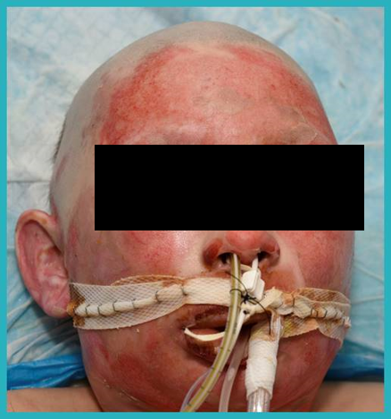

Circulation – Initial fluid resuscitation
- Bolus ONLY for hypotension [SBP = 70 + 2 × age (years)]. Tachycardia is poor marker of resuscitation in burn patient.
- If TBSA >10%, the following fluids should be started during primary survey:

Age/Weight of Child | Initial fluid rate & type  (prior to burn size calculation)
≤5 years old & <10kg | 125mL/hr of D5LR
≤5 years old & >10kg | 125mL/hr of LR
6-14 years old | 250mL/hr of LR
>14 years old | 500mL/hr of LR

- Calculate burn TBSA and convert resuscitation fluids as instructed below under “Burn Fluid Resuscitation”.

Assessment
- Assess for associated injuries.
- History → time and mechanism of injury, enclosed fire or toxic chemicals involved.
- Assess burn and estimate Total Surface Body Area (%TBSA) using the “Burn Estimate and Diagram Form.”
  - First-degree (sunburns) – characterized by erythema, pain, and absence of blisters. First-degree burns are not counted in TBSA calculation.
  - Second-degree (superficial partial thickness or deep partial thickness) – characterized by red or blanching appearance with swelling and blister formation. Surface may have weeping, wet appearance and painfully hypersensitive.
  - Third-degree (full thickness) – skin appears dark and leathery; may also appear translucent, mottled, or waxy white; surface is painless* and generally dry, but may be moist. (*Pain presents at the subcutaneous tissue surrounding or within the burn area).

Burn Fluid Resuscitation
- Bolus ONLY for hypotension.
- Replace volume based on estimate of TBSA.
  - If < 20% TBSA, burn fluid resuscitation is not indicated. Discontinue IVF or decrease to MIVF unless otherwise indicated or patient unable to take PO.
  - If > 20% TBSA, start 2-bag resuscitation per the following:
    - Initiate two large bore IVs; overlying burns should not prevent IV placement (upper extremities preferred)
    - Bag 1: Follow the Pediatric Burn Formula [3ml x % TBSA burned x weight (kg)] / 16 = ml/hr LR (never add dextrose to Bag 1 fluids).
    - Bag 2 if < 30 kg: Calculate MIVF of D5LR.
- Place urinary catheter. Initial output should not count towards hourly output. Titrate Bag 1 rate hourly according to individual patient's response:
  - < 15 years and < 50 kg: goal UOP = 1.0 ml/kg/hour
    - If UOP < 1ml/kg/hr, increase fluids by 10%
    - If UOP > 1ml/kg/hr, decrease fluids by 10%
  - > 15 years or > 50 kg: goal UOP = 30 ml/hr
    - If UOP < 30ml/hr, increase fluids by 10%
    - If UOP > 30ml/hr, decrease fluids by 10%
- Place feeding tube and start enteral feeds within 12 hours if medically stable and unable to take PO. Feeds held for sedation per KCH policies. Wean Bag 2 fluids as enteral feeds are increased.
- Monitor finger stick glucoses every 1-2 hours until stable.
- Continue resuscitation fluids until enteral intake is sufficient to maintain adequate UOP and patient has had full thickness burns excised. Patients will have an ongoing inflammatory response, capillary leak and relative intravascular hypovolemia.

Basic Wound Care
- Remove affected clothing if not already done and anything wet/cold.
- Cover burns with dry dressing.
- Patients for whom transfer is directed by Shriners Hospital: no need to wash, debride or apply topical medications.
- Patients for whom outpatient referral is directed by Shriners Hospital:
  - Wash burn with soap and water if visibly dirty. One wipe is sufficient; no need to debride loose skin.
  - Apply antibiotic ointment to non-adherent dressing. DO NOT USE SILVER SULFADIAZINE.
  - Place dressing directly on burn and wrap lightly with gauze, maintaining full range of motion.
- Wound Care for those not transferred or referred:
  - Superficial partial thickness: Mepilex AG, wrap with kerlix or stretch net
  - Deep partial thickness: bacitracin with Adaptic or Vaseline gauze; Dermanet for larger areas; pad with 10 ply burn gauze, wrap with kerlix/stretch net. Transition to Mepilex AG prior to discharge home.
  - Full thickness burn: can use Silvadene for older for than 2 months of age.

Circumferential burns
- Extremities:
  - Remove rings and bracelets and assess distal circulation.
  - Check pulses with Doppler.
  - Observe for cyanosis, impaired capillary refill, or progressive neurological signs (i.e. paresthesia and deep tissue pain).
  - Limb Escharotomy:
    - Relieve compromised distal circulation in circumferentially burned limb by escharotomy, which can be done with sedation or local anesthesia in lieu of general anesthesia, due to insensitive full thickness burn.
    - Incision must extend across entire length of eschar in lateral and/or medial line of limb including fingers and joints.
    - Incision should be deep enough to allow cut edges of eschar to separate.
    - Escharotomy should be performed through burned skin when possible.
- Thorax/Abdomen/Neck
  - Circumferential burns of thorax can impair respiratory excursion.
  - Circumferential burns of abdomen can cause abdominal compartment syndrome.
  - Circumferential burns of neck can cause airway compromise.
  - Thoracic Escharotomy:
    - Bilateral, mid-axillary escharotomy incisions should be considered.
    - Escharotomy should be performed through burned skin when possible.

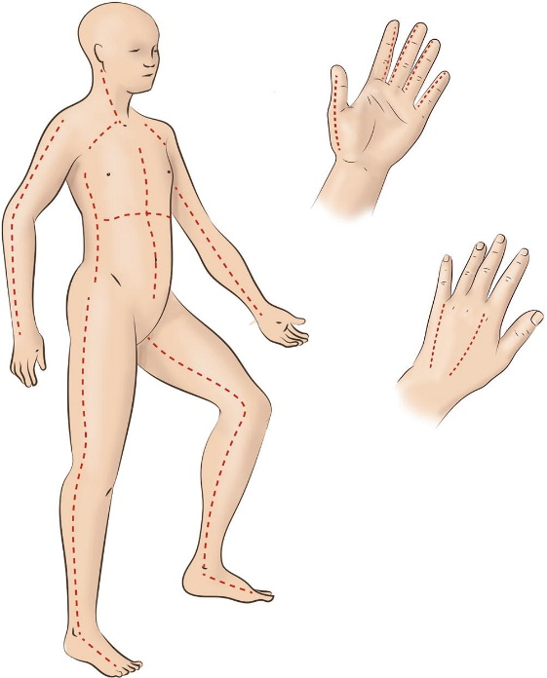

Inhalation Injury
- Those with carbonaceous sputum or trapped in house fire should be presumed to have suffered inhalation injury
- Assess for CO and cyanide toxicity (see prior section under “stabilization”)
- Confirmed with use of fiberoptic bronchoscopy.
  - Identification of edema, inflammatory changes to tracheal mucosa, carbonaceous material in airway
  - Some changes do not manifest until 12-24 hours after injury so repeat bronchoscopy may be indicated if high suspicion.
- Management is focused on treatment of associated bronchospasm and airway occlusion.
  - Bronchodilators
  - Racemic epinephrine to decrease mucosal edema
  - Aggressive pulmonary toilet
    - Inhaled heparin and acetylcysteine can help clear secretions
    - Consider daily bronchoscopy to clear airways

Special Burn Considerations

Chemical burns
- Brush dry powder off before irrigation.
- Irrigate burns with water for at least 20 to 30 minutes; alkali burns require longer irrigation.
- Alkali burns to the eye require continuous irrigation during first 8 hours – consult Ophthalmology.

Electrical burns - frequently more serious than they appear on the surface
- Initial care as above including EKG monitoring and urinary catheter placement.
- Full spinal immobilization.
- Observe for myoglobinuria (due to rhabdomyolysis); consult with burn center regarding alkalization of fluids.
- Increase IVF rate to ensure UOP 1–1.5 mL/kg/hr in children weighing less than 30 kg or 100 ml/hr in adults. Once urine is clear of pigmentation, titrate IVF down to ensure standard UOP as described above.

Explosive Injuries
- Any patient involved in an explosion has mechanism for traumatic injuries.
- Even if child was not thrown, a flash flame explosion can have enough energy to cause mild TBI (concussion).

Other Pediatric Considerations
- Consult Child Life for all burn patients.
- Consult Pediatric Forensic Medicine Service and/or DCBS if injury due to suspected abuse, neglect, or safety hazards in the home.
- Consider Pediatric Psychiatry or Psychology consult to help child cope with hospitalization, body image changes, and/or acute stress disorders.
- Asses tetanus immunization status and provide immunization per AAP Red Book recommendations: https://redbook.solutions.aap.org/chapter.aspx?sectionId=189640195&bookId=2205&resultClick=24#192303674

Resources:
- Shriners Children’s Ohio is available 24/7 to assist with management of burn patients. Call 855-206-2096 and ask to speak with the Charge Nurse.

